1. Create a stored procedure in the Northwind database that will calculate the average
value of Freight for a specified customer.Then, a business rule will be added that will
be triggered before every Update and Insert command in the Orders controller,and
will use the stored procedure to verify that the Freight does not exceed the average
freight. If it does, a message will be displayed and the command will be cancelled.

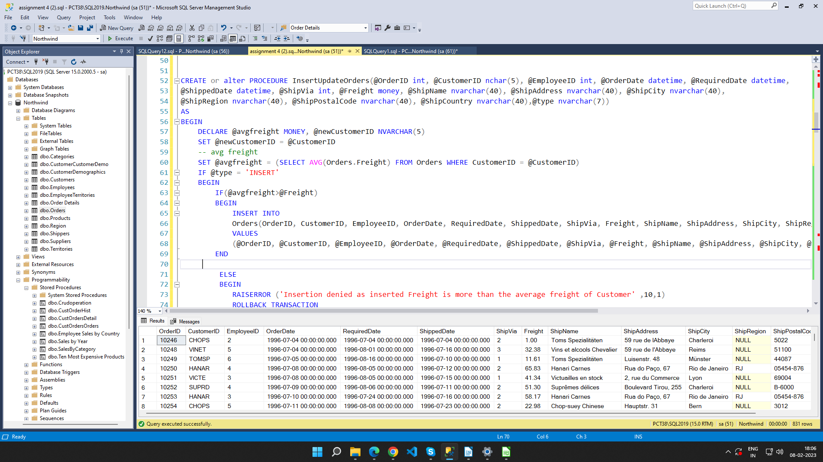

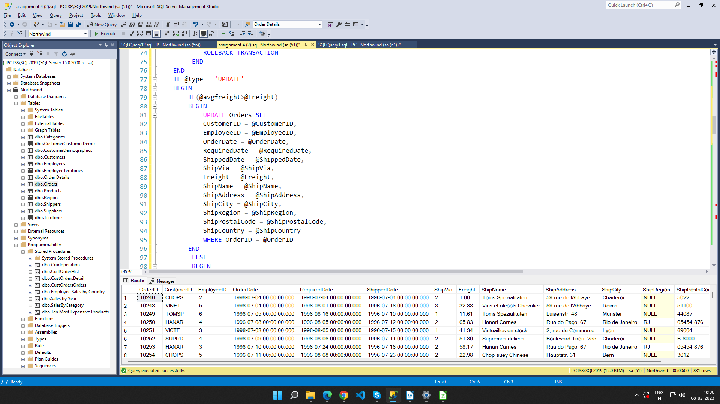

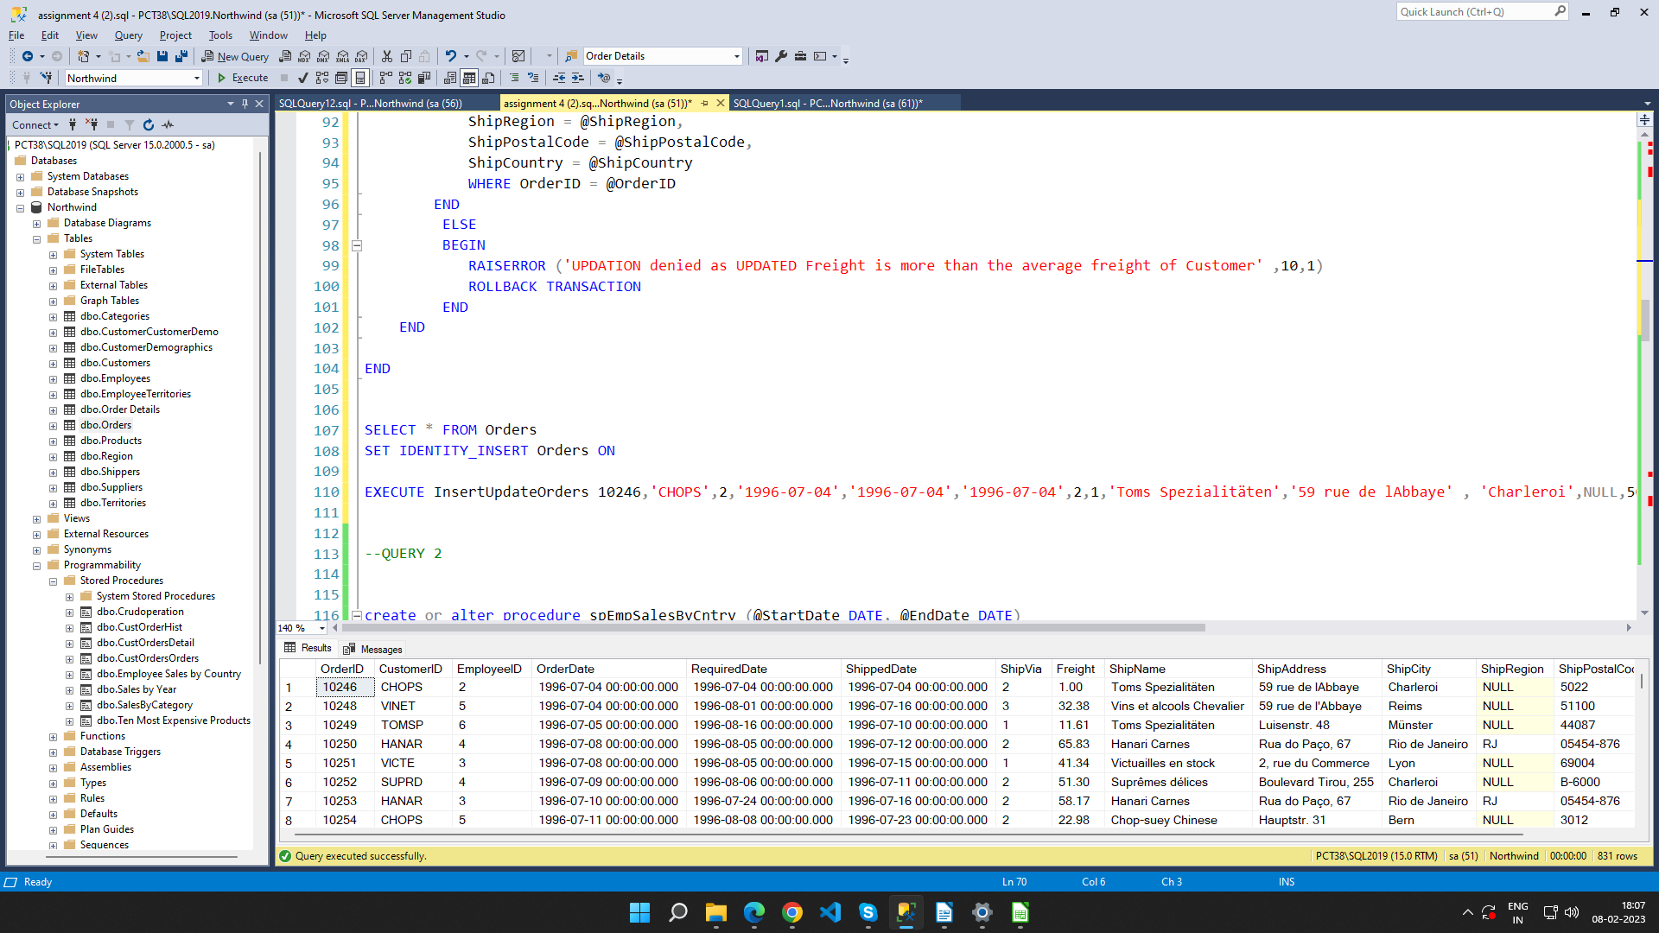

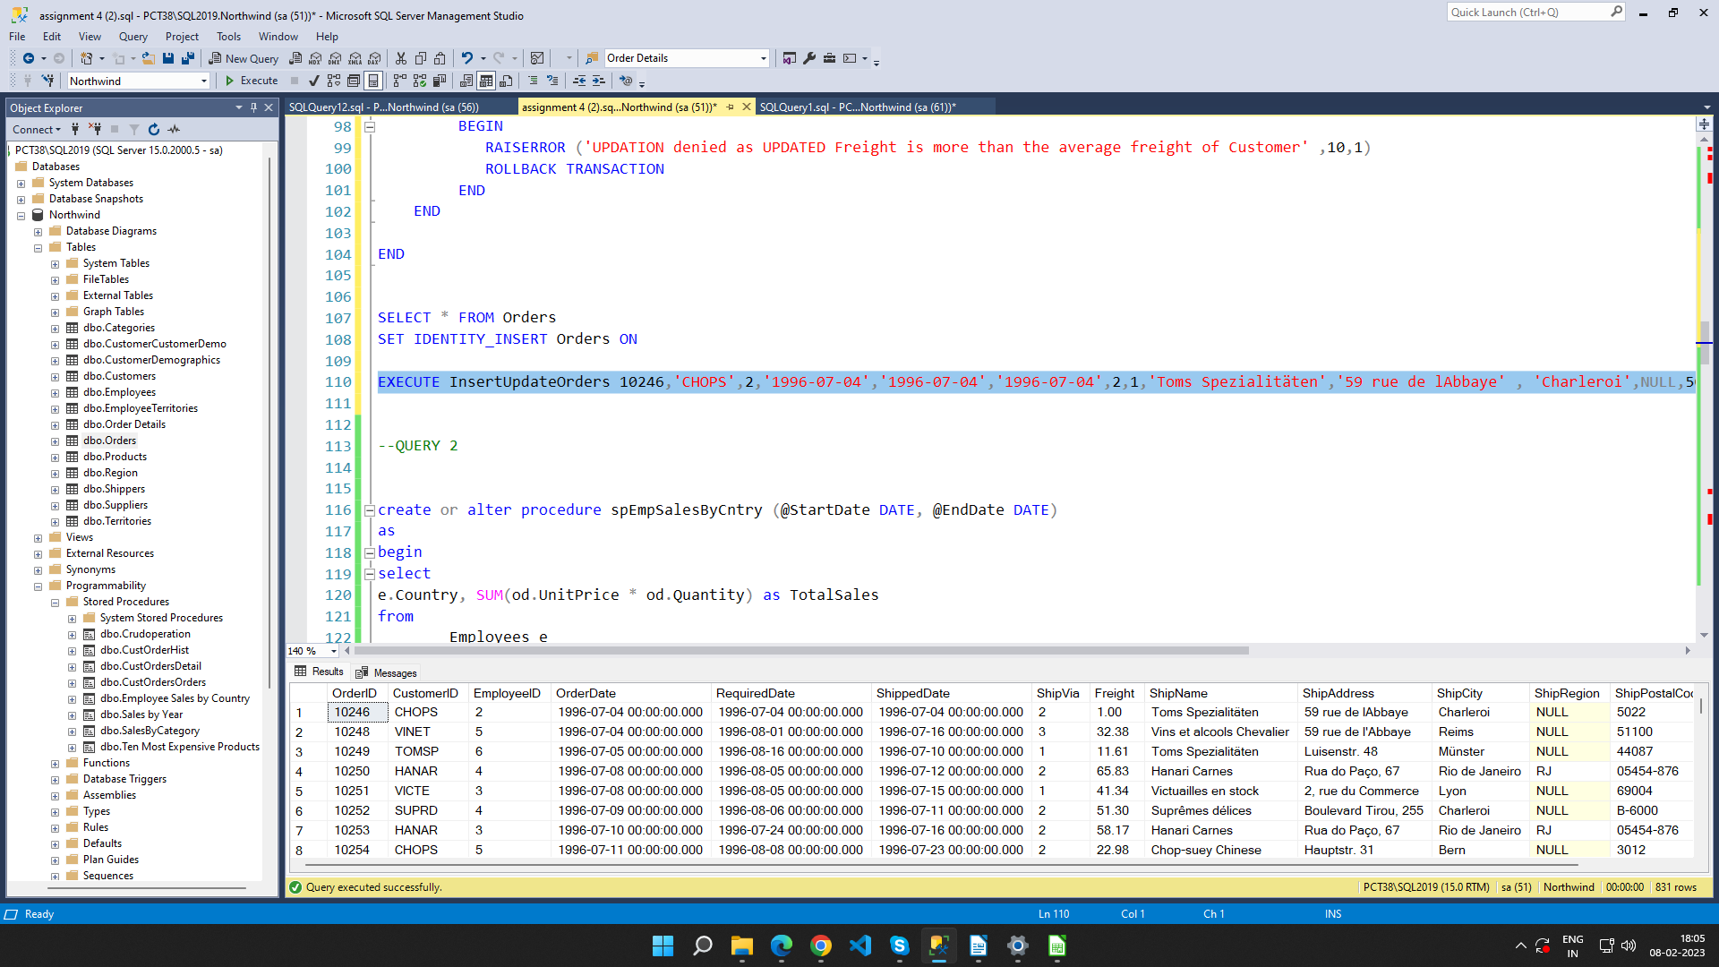

2. write a SQL query to Create Stored procedure in the Northwind database to retrieve
Employee Sales by Country

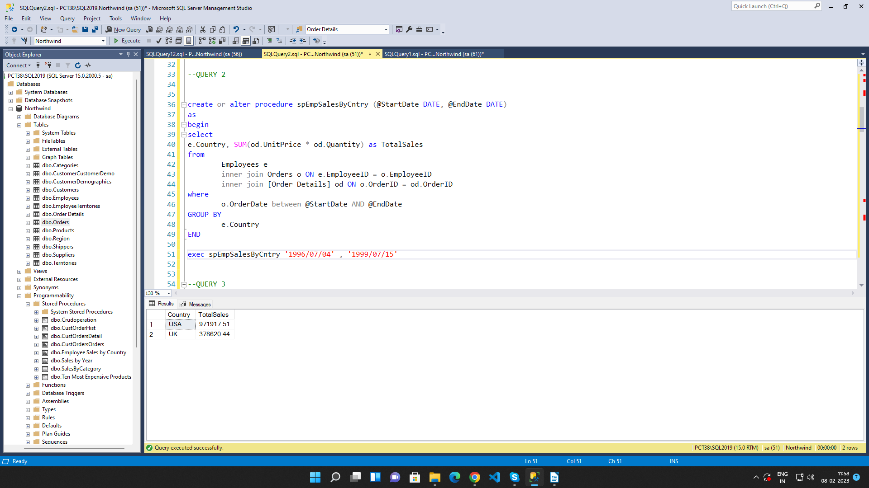

3. write a SQL query to Create Stored procedure in the Northwind database to retrieve
Sales by Year

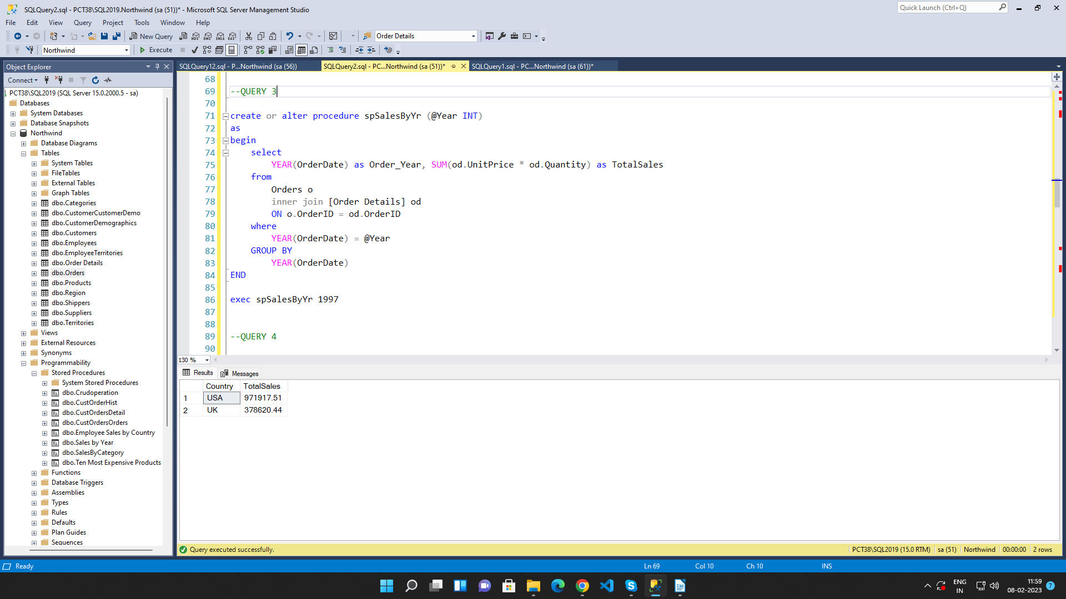

4. write a SQL query to Create Stored procedure in the Northwind database to retrieve
Sales By Category

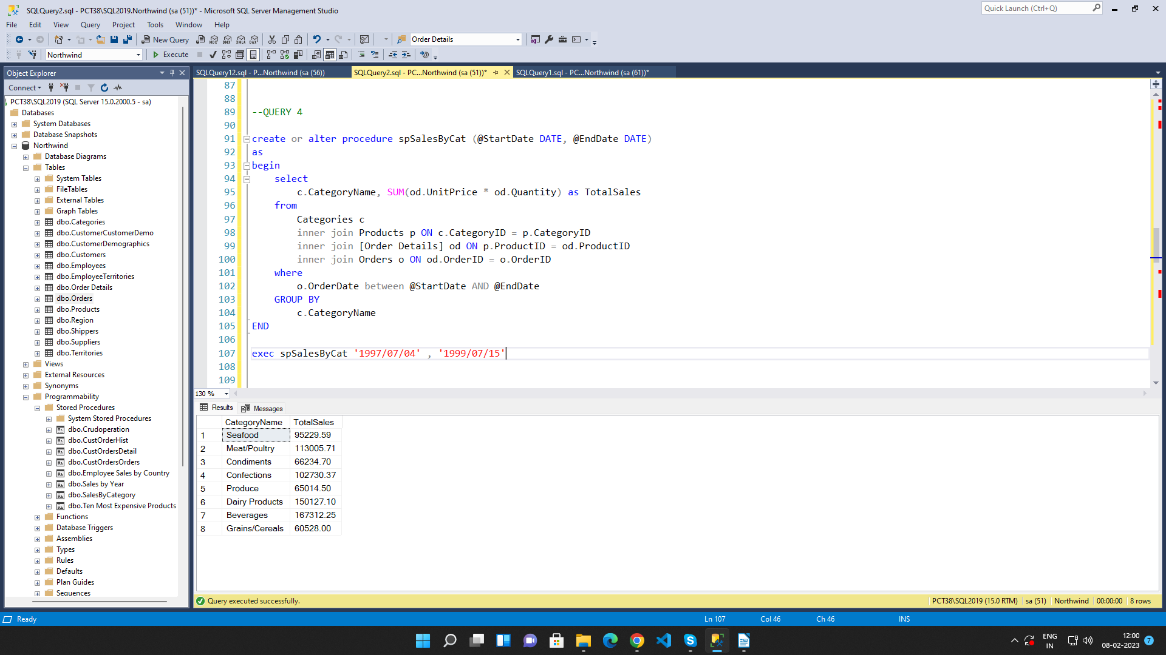

5. write a SQL query to Create Stored procedure in the Northwind database to retrieve
Ten Most Expensive Products

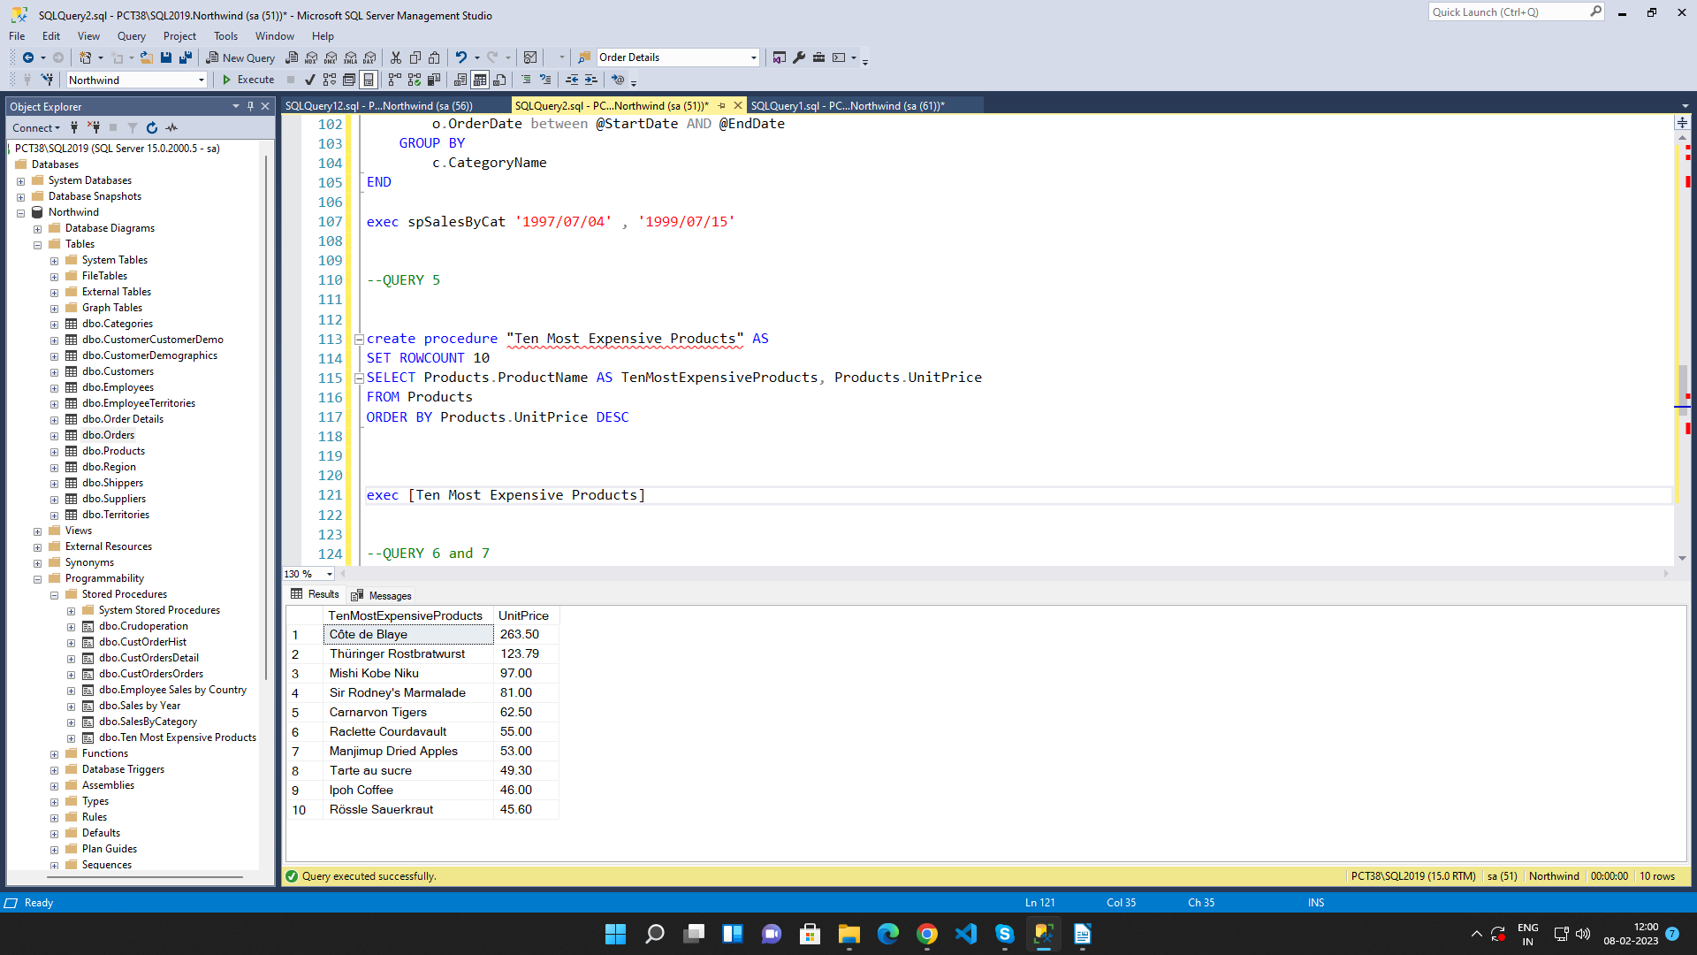

6. write a SQL query to Create Stored procedure in the Northwind database to insert
Customer Order Details
And
7. write a SQL query to Create Stored procedure in the Northwind database to update
Customer Order Details

